Puget Sound Olympia oyster performance in a reciprocal transplant experiment

Methods
Broodstock Conditioning and Outplanting
Adult oysters were collected from three locations in Puget Sound (Fidalgo, Dabob, and Oyster Bays) during November and December 2012. Mass spawning of oysters occurred in June 2013 following several months of conditioning. Larvae were raised in flowing seawater and fed microalgae. Following setting on microcultch, juveniles were cultured in flowing seawater in Port Gamble. In August, 480 oysters (5-10 mm) from each population were planted at Fidalgo, Oyster Bay, Dabob, and Manchester Bays. At each site, oysters from each population were placed into four 0.61M X 0.61M growout trays (120 each). In each tray, oysters were equally distributed in four 10x7.5cm mesh (1475 micron) bags with 24 oysters glued to ceramic tiles. Trays were anchored into substrate using using rebar stakes. In late autumn trays at Fidalgo Bay, Oyster Bay, and Manchester were transferred from substrate to a midcolumn hanging groups of three were ziptied, roped together, and caribine clipped to a hanging rope tied to a floating dock. At each site, a HOBOlogger temperature logger (OnSet, USA) was deployed to monitor temperature every 15 minutes.

Site Monitoring and Growth
Survival and growth were assessed at all sites in December 2013, Dabob in January 2014, and Fidalgo, Manchester, and Oyster Bays in February 2014. Survival was measured by counting all live animals remaining in each tray for each population in each of three months monitored. Mortality was calculated through counts of all dead individuals in each tray. In December 2013 at Dabob Bay, we counted the live samples as we opened windscreen bags which contained 1/4th the population in each tray. We then multiplied this number by 4 to get a rough estimate of the live animals for the tray. Growth was measured via size and weight measurements taken directly from live subsamples collected in the field and measured in the lab. In the lab each of the sampled oysters was measured using calipers for hinge to bill length and weighed with shell to determine whole body weight. Live samples were not collected in February 2014 due to low mortality instead photographs were taken to document size through an image analysis program (ImageJ).

 | August 2013 | September  2013 | October 2013 | November  2013 | December 2013 | January  2014 | February  2014
Visited | F,M,O,D | No | F,O,D | M | F,M,O,D | D | F,M,O
Metrics | Size | No | No | No | S,W,L,D | S,W,L,D | S,L,D
Genetics Samples | Yes | No | No | No | F,M,O,D | D | No
Fid |  |  |  |  | 96
Man |  |  |  |  | 95
Oys |  |  |  |  | 94
Dab |  |  |  |  | 152 | 94
Table 1. This table denote actions taken in each month of the survey period in regards to field work. In the Visited and Genetic Samples rows F = Fidalgo, M = Manchester, O = Oyster Bay, and D = Dabob. In the Metrics row S = Size, W = Weight, L = Live Count, and D = Dead Count. Numbers are exact numbers of samples collected at each site.

Sample Collection
Samples for genetic testing were collected at outplanting in August 2013 for baseline data. Then in December 2013 following a major mortality event at Dabob and prior to any more freeze events at Fidalgo, Oyster, and Manchester Bay we took another genetics sample. These samples comprised of approximately 32 animals per population at Fidalgo, Manchester, and Oyster Bays. At Dabob we collected 43 from the Fidalgo population, 50 from the Oyster Bay population, and 59 from the Dabob population due to the high mortality. We visited Dabob again in January to collected another 22 from the Fidalgo population, 33 from the Oyster Bay population, and 39 from the Dabob population.

Results
Temperature Monitoring
From outplanting until collection January and February, HoboLoggers have been recording temperature fluctuations at each site every 15 minutes. The graphs below show the logs over time for each site.

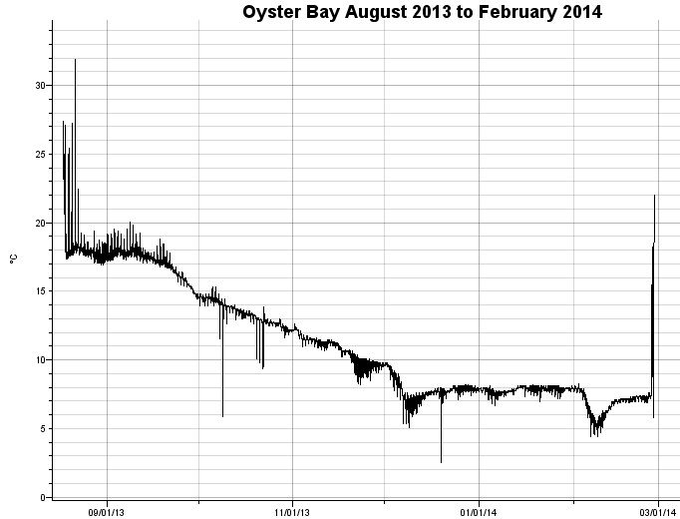
Graph 1. Temperatures at Oyster Bay from outplanting in August 2013 to retrieval in February 2014. Mid to late October drops are correlated with moving the tray from original site to new site.

Oyster Bay | Min Temp C | Max Temp C | Average Temp C | STDev
August 2013 | 16.903 | 31.88 | 18.123 | 1.238
September 2013 | 14.421 | 20.043 | 17.067 | 1.048
October 2013 | 5.86 | 15.282 | 13.35 | 0.918
November 2013 | 8.182 | 12.594 | 10.673 | 0.913
December 2013 | 2.517 | 9.768 | 7.771 | 0.812
January 2014 | 6.674 | 8.182 | 7.81 | 0.21
February 2014 | 4.415 | 8.282 | 6.808 | 0.765
Table 2. Shows the Min, Max, and Average temperatures as well as the Standard Deviation between samples at Oyster Bay for each month of the survey period. August is calculated from August 17th onward. Bold temperatures denote lowest temperature and highest temperature recorded within the trays. Bold Italicized temperatures are the lowest and highest average temperatures.

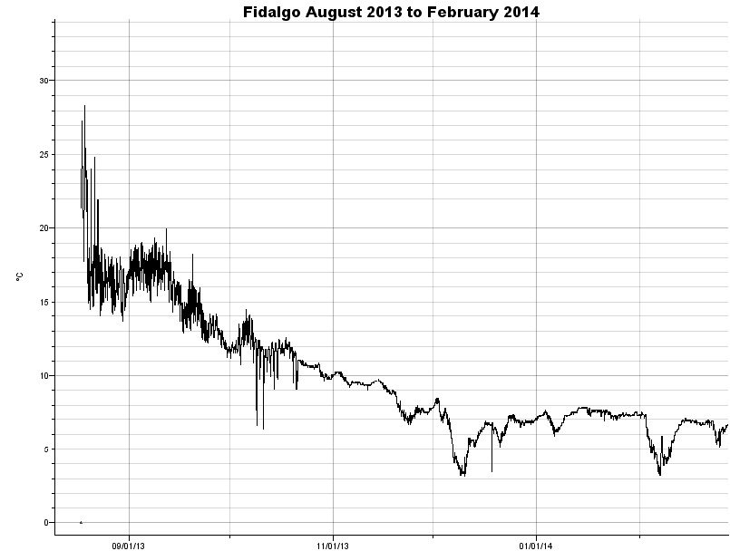
Graph 2. Temperatures at Fidalgo from outplanting in August 2013 to retrieval in February 2014. Dip in mid to late October correlate with moving trays from original site to new hanging site.
Fidalgo | Min Temp C | Max Temp C | Average Temp C | STDev
August 2013 | 13.654 | 28.357 | 17.422 | 2.701
September 2013 | 11.236 | 19.948 | 15.356 | 2.009
October 2013 | 6.37 | 14.517 | 11.354 | 1.041
November 2013 | 6.674 | 10.259 | 8.764 | 1.011
December 2013 | 3.155 | 8.481 | 6.235 | 1.184
January 2014 | 5.86 | 7.882 | 7.309 | 0.389
February 2014 | 3.261 | 7.582 | 6.064 | 1.016
Table 3. Shows the Min, Max, and Average temperatures as well as the Standard Deviation between samples at Fidalgo for each month of the survey period. August is calculated from August 17th onward. Bold temperatures denote lowest temperature and highest temperature recorded within the trays. Bold Italicized temperatures are the lowest and highest average temperatures.

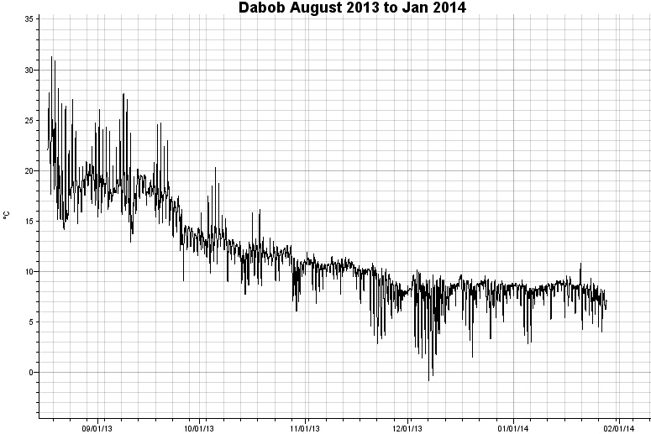
Graph 3. Temperatures at Dabob from outplanting in August 2013 to retrieval in February 2014.

Dabob | Min Temp C | Max Temp C | Average Temp C | STDev
August 2013 | 14.134 | 31.268 | 19.103 | 2.777
September 2013 | 9.077 | 27.665 | 17.127 | 2.475
October 2013 | 6.054 | 20.329 | 11.87 | 1.487
November 2013 | 2.837 | 11.916 | 9.49 | 1.581
December 2013 | -0.774 | 10.161 | 7.711 | 1.68
January 2014 | 2.837 | 10.846 | 7.971 | 1.052
Table 4. Shows the Min, Max, and Average temperatures as well as the Standard Deviation between samples at Dabob for each month of the survey period. August is calculated from August 17th onward. Bold temperatures denote lowest temperature and highest temperature recorded within the trays. Bold Italicized temperatures are the lowest and highest average temperatures.

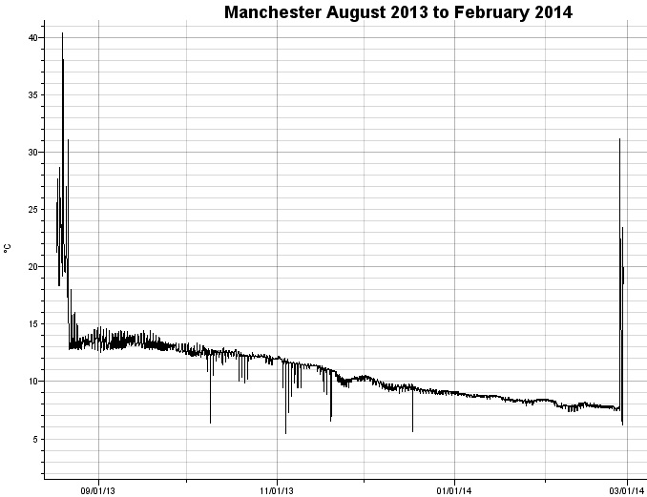
Graph 4. Temperatures at Manchester from outplanting in August 2013 to retrieval in January 2014. Dip in mid to late November correlate with moving trays from original site to new site.

Manchester | Min Temp C | Max Temp C | Average Temp C | STDev
August 2013 | 12.69 | 40.415 | 16.154
September 2013 | 12.401 | 14.804 | 13.283 | 0.466
October 2013 | 6.37 | 13.365 | 12.34 | 0.402
November 2013 | 5.45 | 12.207 | 10.896 | 0.799
December 2013 | 5.655 | 10.553 | 9.45 | 0.439
January 2014 | 7.882 | 9.077 | 8.561 | 0.248
February 2014 | 7.381 | 8.481 | 7.899 | 0.225
Table 5. Shows the Min, Max, and Average temperatures as well as the Standard Deviation between samples at Manchester for each month of the survey period. August is calculated from August 17th onward. Bold temperatures denote lowest temperature and highest temperature recorded within the trays. Bold Italicized temperatures are the lowest and highest average temperatures.

As can be seen from Graphs 1,2, and 4 temperatures remained consistent over time after being moved from intertidal areas to hanging docks. Whereas in Graph 3 for Dabob, there were wild and constant fluctuations in temperature due to changes in air temperatures, tides, and freshwater influx. From Tables 2-5, it can be seen that oysters at Dabob experienced subfreezing temperatures but normal average temperatures when compared to the other sites. Conversely Manchester saw the highest temperatures with a sublethal 40 C temperature experienced during outplanting.

Mortality Monitoring
Sites were visited in December and January/February to check for growth and mortality. The graphs below are exact mortality counts based on dead oysters collected from each tray and counted in the lab.

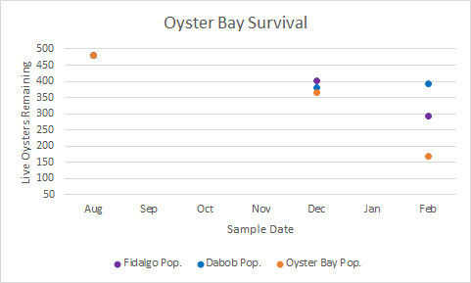
Graph 5. Scatter plot indicating number of remaining animals in each population after sampling at Oyster Bay. 2 trays of Oyster Bay animals as well as 1 tray of Fidalgo animals have gone missing at Oyster Bay due to equipment failure. Trend present in graph is thought to be false.
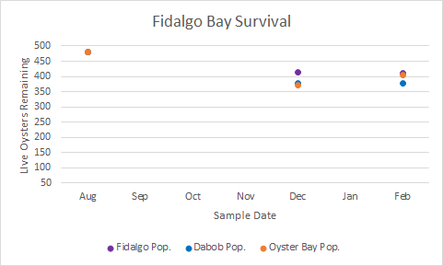
Graph 6. Scatter plot indicating number of remaining animals in each population after sampling at Fidalgo Bay.
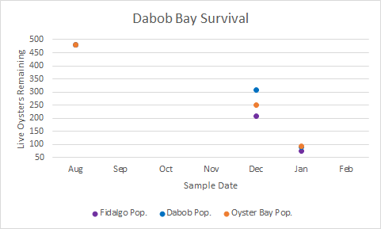
Graph 7. Scatter plot indicating number of remaining animals in each population after sampling at Dabob Bay.

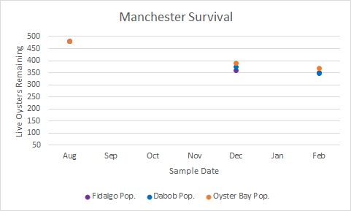
Graph 8. Scatter plot indicating number of remaining animals in each population after sampling at Manchester.

In graphs 6 and 8 there is little mortality occurring at each of these sites. Graph 5 is suggested to appear similarly if it were not for the missing trays. Graph 7 shows that Dabob has had two major mortality events and will likely die out in the coming months. Dabob also shows differential mortality between populations at December with the native population having higher survival than the two foreign populations. While not shown to be significantly different, there does appear to be a trend forming between populations.

To get a better understanding of what is driving the mortality events at Dabob we combined the temperature logs graphs with the mortality graphs.

Environmental and Mortality Monitoring

Below are the combinations of the mortality graphs with their respective temperature graphs. This is to visualize possible causes for mortality events at Dabob.

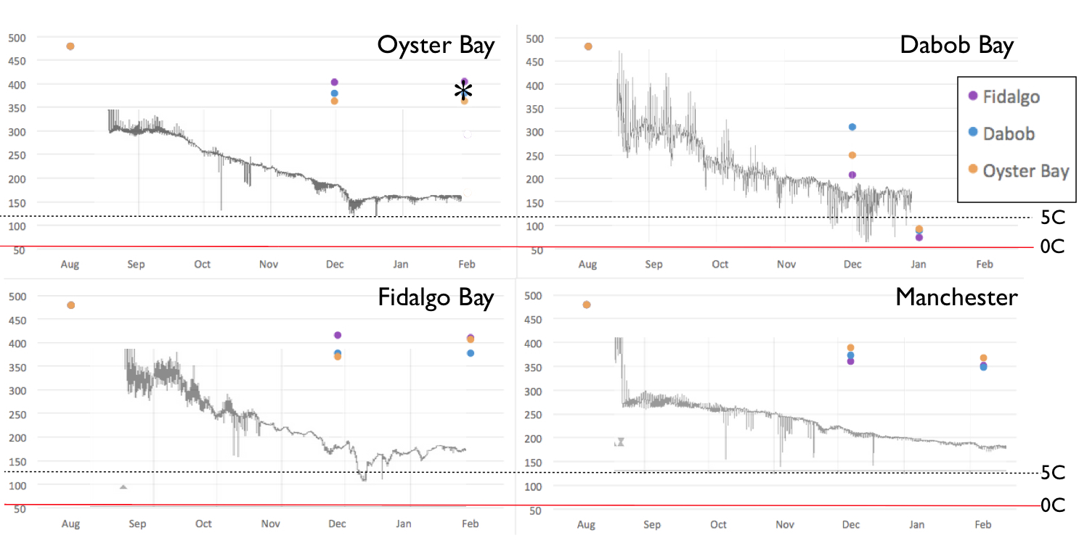
Chart 1a/b/c/d. These graphs show temperature logs overlaid on mortality data to correlate mortality changes over time with temperature changes and extreme events. In Chart 1a, the asterisk indicates the estimated mortality if missing samples were accounted.

When comparing Dabob temperatures with mortality it is evident that temperature fluctuations and extreme cold events are related to the mortality events. All over sites show relatively little mortality with temperatures cold but consistent over time. When comparing extremes of hot and cold with mortality its interesting to note that Dabob experienced subfreezing temperatures at some point in December but normal average temperatures the rest of the time. Conversely Manchester experienced sublethal high temperatures above 40C but with average temperatures overall. The extreme cold seems to be a better indicator of mortality events from the winter than that of the extreme heat at Manchester at the tail end of Summer. It is from this we suggest that conditions within Dabob Bay are considerably more stressful than at the other sites which has led to significant mortality overtime.

Size Info
Another metric used to judge success of populations at each site was growth. We measured growth in December and January by measuring random subsamples from each site. On average the animals were put out at slightly different sizes which may have had an effect on the differences between populations. There is a clear difference in growth trajectories from each site due to environmental conditions.

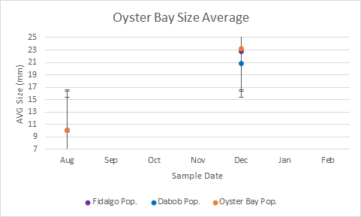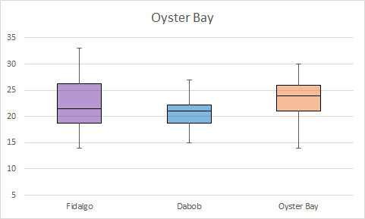
Graph 9a/b. 9a shows changes in shell length at Oyster Bay from August to December 2013. 9b shows difference in grow between all populations in December.

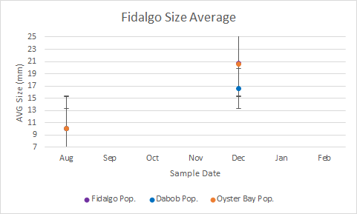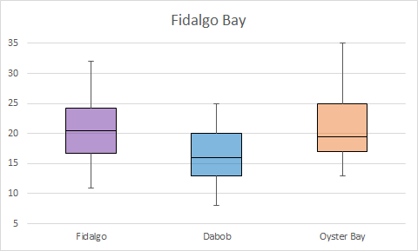
Graph 10a/b.10a shows changes in shell length at Fidalgo Bay from August to December 2013. 10b shows difference in grow between all populations in December.

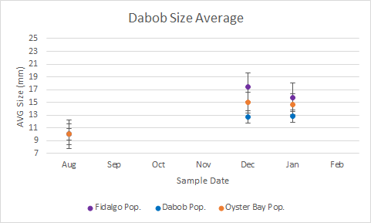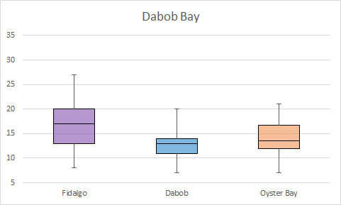
Graph 11a/b. 11a shows changes in shell length at Dabob Bay from August 2013 to January 2014. 11b shows difference in grow between all populations in December.

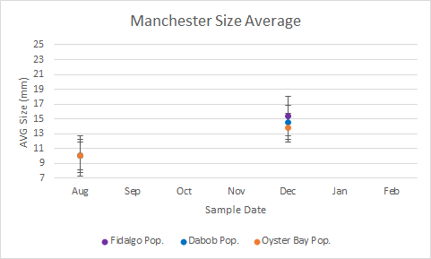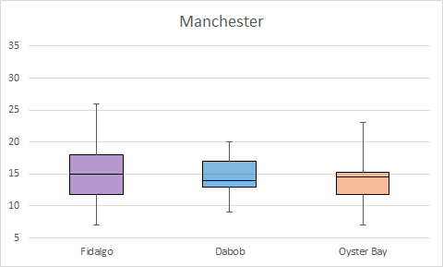
Graph 12a/b. 12a shows changes in shell length at Manchester from August to December 2013.
12b shows difference in grow between all populations in December.

At Fidalgo and Oyster Bays, graphs 9a and 10a, growth in all populations is larger than at Dabob and Manchester, graphs 11a/12a. This could indicate that conditions for food and micronutrients are much better than at Manchester and Dabob. This could also be the reason we see much better growth in the Fidalgo and Oyster Bay populations as they are more apt to take advantage of prosperous conditions in their native habitat.

In graphs 9b, 10b, and 11b. There is a clear pattern between the sizes of each population with Fidalgo having the majority of the population be of a larger size but with Oyster Bay having the largest size range. Dabob seemingly doesn’t grow very large or have a very large range of sizes in growth. At Manchester this dynamic is changed somewhat with the majority of the Dabob population growing larger than the majorities of Fidalgo and Oyster bay.

Overall the differences in size at each site are small and have not been seen to be significantly different from one another. Moving forward we hope to see a much larger difference between populations in size and mortality. Trends present within data give clues to possible areas of future research into the differences in each population such as differences in resource allocation, stress tolerance, and time to maturity. It is hoped that with further study, clear differences between phenotypes and genotypes will indicate whether true local adaptation exists or whether environmental conditions dictate available phenotypes but do not change phenotypes produced each spawning season.

 | 1N | 1H | 1S | Total | 2N | 2H | 2S | Total | 3N | 3H | 3S | Total | 4N | 4H | 4S | Total
December
Live | 433 | 411 | 396 | 1240 | 447 | 410 | 402 | 1259 | 188 | 228 | 216 | 632 | 391 | 405 | 421 | 1217
Dead | 47 | 49 | 51 | 147 | 18 | 20 | 15 | 53 | 229 | 112 | 180 | 521 | 13 | 1 | 11 | 25
Sample | 30 | 32 | 32 | 94 | 32 | 32 | 32 | 96 | 43 | 59 | 50 | 152 | 31 | 32 | 32 | 95
Missing | 0 | 20 | 33 | 53 | 15 | 50 | 63 | 128 | 63 | 140 | 84 | 287 | 76 | 74 | 48 | 198
Remainder | 403 | 379 | 364 | 1146 | 415 | 378 | 370 | 1163 | 208 | 309 | 250 | 767 | 360 | 373 | 389 | 1146
Adj Remain | 403 | 399 | 397 | 1199 | 430 | 428 | 433 | 1291 | 271 | 449 | 334 | 1054 | 436 | 447 | 437 | 1344
January/
February
Live | 292 | 392 | 170 | 854 | 410 | 377 | 406 | 1193 | 96 | 128 | 125 | 349 | 351 | 348 | 367 | 1066
Dead | 15 | 3 | 24 | 42 | 35 | 42 | 27 | 104 | 96 | 52 | 70 | 218 | 5 | 1 | 4 | 10
Sample | 0 | 0 | 0 | 0 | 0 | 0 | 0 | 0 | 22 | 39 | 33 | 94 | 0 | 0 | 0 | 0
Missing | 96 | -16 | 170 |  | -30 | -41 | -63 |  | 16 | 129 | 55 | 200 | 4 | 24 | 18
Remainder | 292 | 392 | 170 | 854 | 410 | 377 | 406 | 1193 | 74 | 89 | 92 | 255 | 351 | 348 | 367 | 1066
Table 2. Table showing Live, Mortality, Missing and Sampled count values for all populations at all sites.

December
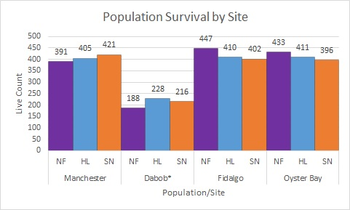

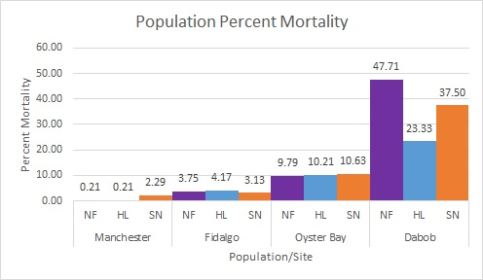

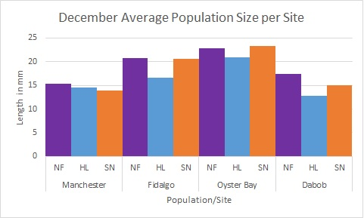

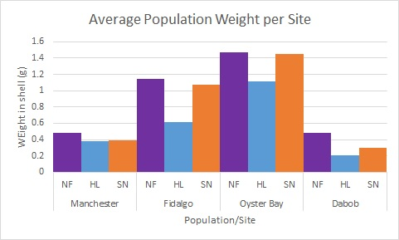

January

Dabob

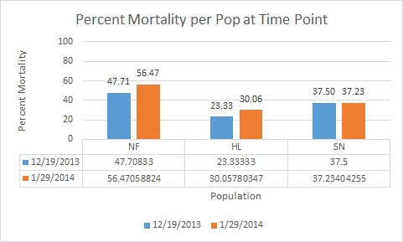

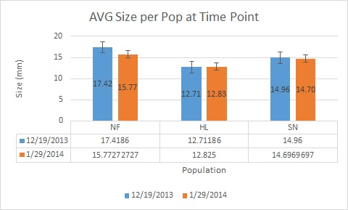

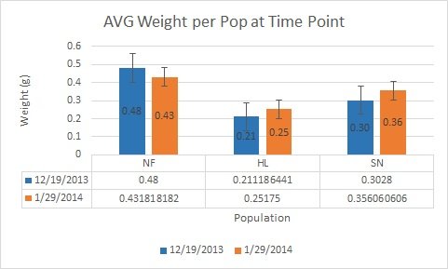

Site Selection
Three sites were selected from geographically disparate regions of the Puget Sound known to contain stable populations of Olympia oysters for broodstock collection and experiment outplanting. Based on Savolainen (2007) we organized these sites along a North/South Axis (Fidalgo Bay, 48.496594, -122.600692; Dabob Bay,47.847482, -122.808296; Manchester Bay, 47.573736, -122.545469; Oyster Bay, 47.573736, -122.545469). This was done to help emphasize any water quality differences associated with latitude. Our third site was located in Dabob bay which exists in upper Hood Canal and is of special interest due to the extensive shellfish production in the area as well as the highly variable water quality conditions. A fourth site at Manchester, WA with no known Olympia oyster population was selected as an outplanting site to as no population would have any known adaptive advantages to the conditions present within the bay..

cut text
----

Site Selection V1
Three sites were selected from around the Puget Sound for sample collection and outplanting. The sites were geographically distinct in line North to South. Each area is known to have an established Ostrea lurida population, that have anecdotally been known for diverse phenotypes. These sites are also subject to distinct and contrasting oceanographic features that are believed to act as impetus for local adaptation.

Fidalgo Bay was selected as it is currently undergoing restoration for olympia oyster populations and is suspected of having an established albeit small native O. lurida population. Located in the Northern most portion of the Puget Sound and adjacent to the Padilla bay reserve, Fidalgo bay is known for its consistently lower year round temperatures, influx of primary production from both sea grass beds within Padilla bay as well as plankton influx from currents generated within the Strait of Juan de Fuca. O. lurida specimens within Fidalgo bay are anecdotally known for their large size and high meat condition index. In previous years the native population has been depressed due to anthropogenic effects including but not limited to shoreline construction and waste water input from local industry. Restoration efforts have put into place with the Pugest Sound Restoration Foundation planting O.lurida seed within Fidalgo bay to supplement the local population.

Hood Canal or more specifically Dabob Bay was selected for a variety of reasons with primarily the production of oysters (though mostly C. gigas) at Taylor Shellfish being of high interest. Dabob bay located off the Northern most portion of Hood Canal has been part of intensive oceanographic, ecological and biological studies for many years with increasing emphasis on local Ostrea lurida populations. Water quality conditions within the bay are affected by both flow of water from central Sound into Hood Canal, bringing large plankton blooms and nutrients, as well as the outflow of the hypoxic waters from Hood Canal. It is also fed by streams from the Olympic peninsula which have been scrutinized for their effects on nearshore pCO2 content and freshwater influx. These conditions are under constant monitoring by NOAA, Taylor Shellfish, and universities such as UW and MIT. O. lurida populations located within Dabob bay are known for their exceptionally small size and relative hardiness under extreme conditions. There is increased interest on how this population is able to deal with extreme pCO2 events that are known to occur within Dabob bay.

Oyster Bay, located in the Southern most portion of the Puget sound is historically known for its production of Olympia oysters as evidenced by the establishment of the Olympia Oyster Company since the early 1900’s. This area was extremely important to the harvests of olympia oysters and underwent extremely population harvest until the mid 1900’s. Local populations have since remained established within the bay but are not considered restored in comparison to historic populations. Also due to the invasion of C. gigas these animals are constantly competing to limited resource and substrate. In recent years the threat of ocean acidification has also become present with local argonite indexes in reduction. Oyster bay retains relative thermal stability and warmer year round temperatures than other sites within the Sound. It also has significant primary production which has been beneficial for the continual commercial shellfish industry within the bay. O. lurida populations within the bay are known for moderate growth and commercially desirable traits for meat condition index. Predation by invasive oyster drills has a significant effect on all native and non native oysters with the majority of mortalities being linked to overpredation.

A fourth bay at Manchester, WA was also selected for outplanting. Clam bay is under constant monitoring from NOAA and the EPA both of which are located on the shores of the bay. This location has no known O. lurida population. Water conditions there are affected significantly by the aquaculture production of various fish species as well as the immigrant population of marine mammals such as Stellar and California Sea Lions. This bay is considered to be novel for the propagation of O. lurida and is therefore valuable in determining any underlying local adaptation effects with each population of O.lurida by either inhibiting or catering to any one population.

Broodstock Conditioning and Outplanting

Between February and May 2013 broodstock animals from each population were collected from the wild from subtidal zones. These animals were then brought the PSRF hatchery to condition until spawning in mid June through July 2013. Animals were allowed to feed on native plankton blooms as well as cultured plankton within the hatchery. All populations were kept at similar temperatures for the entire period of their detainment prior to spawning.

Spawning was induced through thermal shock methods under common garden conditions for each batch of oysters. Once gametes were fertilized, the resulting larvae were allowed to continue through the mouth brooding stage until it was determined that they were ready to set. From this point, larvae were extracted from the broodstock and allowed to set on cultch.

Seed were grown out in common garden conditions with both natural plankton blooms and supplemental plankton for feeding. All seed remained under these conditions until August when outplanting began.

For outplanting, oyster seed were placed into trays which would remain for two years at the outplanting site until conditions required they be removed. The outplanting trays are standard 2 square foot, 4 inch tall, oyster grow out trays commonly used within the oyster aquaculture industry. Four (4) trays were assigned to each population at each outplanting site with a total of twelve trays planted. Each tray contained 120 oysters with 24 being adhered to ceramic tiles within the center for monitoring individual growth and the remaining 96 oysters being placed loosely within the tray. Unable to meet the minimum 10 mm in size (required for the oysters to not fall through holes within the tray) before outplanting, seed oysters were packed into 3” by 4” windscreen bags (WSB) with 24 individuals per bag and four bags per tray. WSBs would be removed once animals reached appropriate size.

Trays were originally placed in the intertidal zone at a within a +1 foot elevation above sea level so as to allow exposure during extreme low tide events. At Oyster Bay, the trays were suspended on rebar metal racks over 1 foot above sea level in an effort to make them accessible during low tide as well as reduce siltation from the soft bottom. In Fidalgo bay, the trays were located within 100 feet from a recreational tressle walking path that has been the focus of restoration efforts in recent years. Trays located at Manchester were placed on a sandy bottom with heavy Ulva (spp.) coverage and a significant population of large dungeness crabs. Dabob bay had trays planted near the opening to Tarboo creek which is a major outflow for freshwater. These trays were placed within a depression on the rocky bottom that retained consistent 5-7 inches of water during low tide events.

In October 2013, it was decided that animals located in Oyster bay, Fidalgo bay, and Manchester needed to be moved due to the threat of exposure to subfreezing. Late October, trays from Fidalgo and Oyster bays were moved from their intertidal outplanting to hanging off floating docks at Fidalgo Marina and Crab Fresh LLC (Dahman’s Docks) respectively. In mid November trays from Manchester were collected via NOAA dive team and hung within a net pen floating dock owned by the Manchester NOAA facility.

Site Monitoring - Growth and Survival

Site Monitoring - Environmental Conditions

OTHER TEXT

Project Goals:
- To determine the effects of local adaptation on three geographically separated populations of Olympia oyster that reside within the Puget Sound and the Strait of Juan de Fuca through phenotypic and genotypic analysis.
- To discover the possible causes of these differences through environmental analysis.
- To investigate the way in which selection on phenotypes creates a change in genetic profile with an emphasis on epigenetic mechanisms.

Project Methods:
- Crosstransplanting populations to determine environmental effects on mortality within populations
- Genomic analysis via High Throughput Sequencing
- Epigenomic analysis via Methyl Bisulfide Sequencing
- Controlled experimental exposures to various stressor situations
- qPCR and other techniques to verify presence of phenotypic variance between populations

History of Project:
In Spring 2013, populations residing in Dabob Bay (Hood Canal), Fidalgo Bay (North Sound), and Oyster Bay (South Sound) had broodstock collected by PSRF for restoration efforts. These broodstock were conditioned at the PSRF hatchery and were spawned in mid June 2013 to create an F1 generation of offspring separated by broodstock origin. These offspring were reared under common conditions within the hatchery until August 2013.

The F1 generation was then separated into 4 out planting groups which would be planted at the original three sites (Dabob, Fidalgo, and Oyster Bays) as well as a 4th novel site (Clam Bay, Central Sound) to act as an outlier group. Each population at each site contained 480 animals that were divided into 4 containment trays. Due to the small size of the oysters upon outplanting, the animals were placed in 4 windscreen bags per tray to eliminate the possibility of losing the animals through the holes within the trays.

The trays were aquaculture grow out trays that had 4 ceramic tiles affixed to them with 6 oysters attached via super glue for individual growth measurments and a mesh top affixed to them so exclude larger predators from destroying the samples within the trays. 4 trays from each population with a total of 12 trays at each site were transported to each site. At each site the trays were placed on intertidal zones at approximately 1 foot above sea level. Trays in Oyster Bay were affixed to a rebar structure to raise them to the appropriate height and suspend them above a muddy bottom. All other trays were located on a rock or sandy bottom within one or two rows perpendicular to the flow of the tide. This was to eliminate an effect caused by one tray blocking water flow from the other trays and allow direct equal access to nutrients from tidal flows. These trays also contained 2 HoboLogger Temperature monitoring pendants which took ambient water temperature every 15 minutes and store the information for later retrieval. These trays were then left alone until October 2013.

The trays at Dabob, Fidalgo, and Oyster bay were checked for growth in mid October 2013. Animals that had grown to the appropriate size were opened and released into trays as they were large enough not to fall through the holes in the tray. Due to human error we were unable to check the samples within Manchester Bay but assumed they would be still at an acceptable size until they could be retrieved at a later date.

At this point it was determined that the trays at Oyster, Fidalgo, and Manchester (indirectly) were at risk of freezing (that would have caused indiscriminatory mortalities) and warranted a switch from sitting on the bottom. Dabob Bay samples did not warrant this change as it was determined that they sit within a low spot on the tidal flat that never full drains which leaves at least 3 inches of water on top of the oysters at any given time during low tide.

After some deliberation it was determined that we could hang the trays in stacks of 3 off of floating docks and piers at Fidalgo, Oyster, and Manchester Bays. To build the hanging stacks, the protective mesh on the top of each tray was removed except for the tray on the very top of each stack. Two pieces of 6 foot, 0.21 in diameter rope were laced perpendicularly to one another through pre drilled holes in the trays and protect mesh screen. The ends of each rope were tied to themselves using a Huntsman’s Bend knot to best utilize the small amount of rope left on each end while providing the maximum amount of hold. A screw style, galvanized stainless steel caribiner was then used to attach the two ropes to a hanging rope, of 10-12 feet in length and 0.43 to 0.56 inches in diameter, that itself was attached to the floating dock.

In late October 2013, the trays at Fidalgo and Oyster Bays were moved from their original placement to new hanging stacks at Fidalgo Marina and the Crab Fresh (Dahman’s Dock) respectively. On October 19th/20th samples at Fidalgo Bay were removed from their intertidal position and moved to Fidalgo Marina. This brought them a few miles closer to the mouth of the away from the the middle bay area where they were first positioned. The samples were the organized and hung off the floating dock at the marina. It was decided upon viewing the site that the samples needed to hang roughly between 6-10 feet in the water column to avoid damage from any watercraft passing over them. A low traffic area close to shore was chosen along the floating dock and the samples were hung within 3 or so hours. These samples now sit roughly halfway into the water column which will provide stronger waterflow through the traps. The increased flow reduces the risk of sedimentation that had prior been building up on the trays. In their original position the trays had collected over 3 inches of sediment on tiles. This flow through would also increase the animals exposure to nutrients within the water column.

On October 21st/22nd, trays at Oyster Bay were collected and moved to Dahman’s floating dock. The same procedure was followed here as it was in Fidalgo with one exception. The trays were hung in protected area at the end of the dock to reduce any disturbances they might have on the daily operations on this aquaculture dock. They are suspended between 6-10 feet below the dock but the height of the water column is only about 13 feet which at times leads to the trays sitting on the bottom during extended low tides. Also nutrient flow might be affected as there are pumps on the dock to increase waterflow to grow out containers. We attempted to place the hanging trays in an area unaffected by the outflow but their still might be some effects of outflow.

Late in October we attempted to move the trays at Manchester but were unsuccessful, again due to the lack of a GPS coordinates. These sampling trays were finally moved on November 19th with help from the NOAA dive team who collected the trays and brought them back to the docks for us. The windscreen bags were opened in each tray and the trays were organized into hanging devices to hang off the floating dock inside a predator exclusion net.

The animals in the hanging devices were then allowed to acclimate for a month or more before we returned to each site to sample in December 2013.

From December 17th to December 20th, 2013, all four sites were sampled. We collected the dead from each tray in each population, counted the living in each population, and collected 32 animals per population per site (attempted 64 for Dabob due to mortality event) for later genetic analysis. The results are shown in the following graphs for simplification.

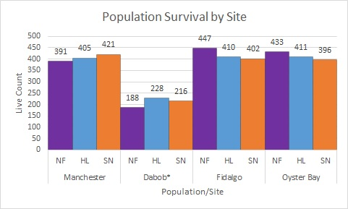
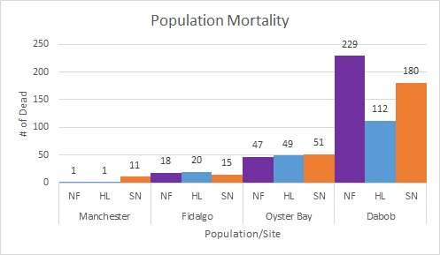
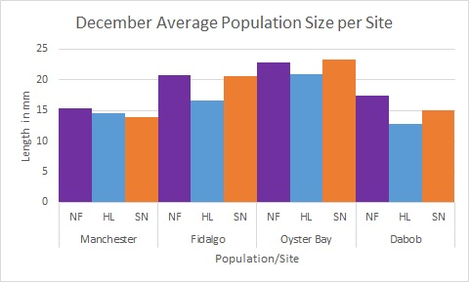
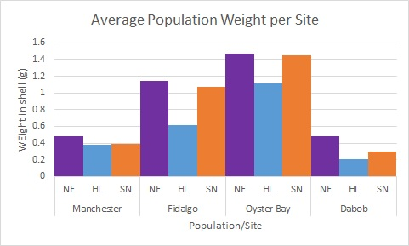

As seen in the Live graph, we had to had estimate the number of living samples at Dabob due to the incoming tide and lack of manpower to count all the trays. From the mortality graph, Dabob underwent a drastic mortality event while the other populations did not. This was thought to be caused by the many hostile environmental effects including those from an extreme cold even that occurred during a low tide in early December.

Due to the extremely low number of survivors at Dabob and continuing cold weather conditions we decided to visit the Dabob site again in January to determine if mortalities were still occurring at Dabob. If so, to collect another set of live samples for genetic analysis.

On January 29th, with a small team of volunteers we headed back out to Dabob to do a full count of survivors and collect samples as necessary. The results are show in the graphs below.
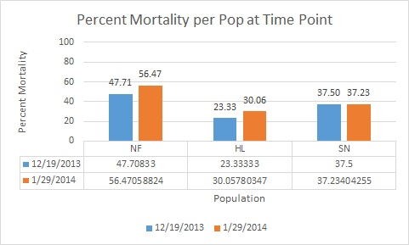
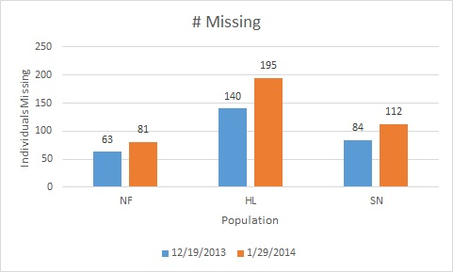
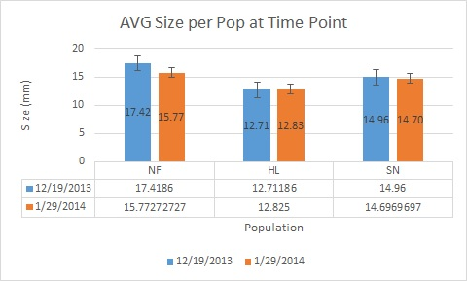
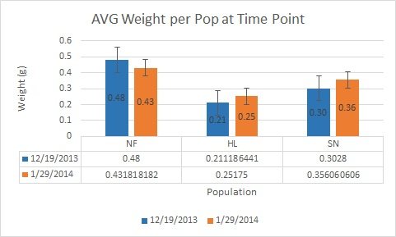

There were a total of 74 live animals from the Fidalgo populations, 121 from the Dabob population, and 118 from the Oyster Bay population. Out of these we sampled 22 from Fidalgo, 33 from Oyster Bay, and 39 from Dabob.

All samples were collected under sterile conditions and stored at -20 for later processing.

------------------------------------

Results

Discussion

